February 10th, 2021
Dear Dr. Daniel Y. Sze, MD, PhD,
I am pleased to present our paper entitled “Use of a novel biomechanical model based deformable image registration (DIR) for assessing colorectal liver metastases ablation outcomes.” We believe that this work will be beneficial for all professionals who perform percutaneous ablation therapy of the liver.
With respect to the major contributions of this work, we feel that it deserves consideration within this journal for several reasons. First, our paper shows the importance of consideration of the deformation in the liver, how rigid registration can lead to a false sense of achieving sufficient ablation margins in certain cases, Figure 1. Second, we demonstrate how our clinical workflow with a novel biomechanical registration, which has previously demonstrated accuracy in deforming homogenous structures in CT, can provide actionable intra-procedural information that might assist the interventional radiologist to assess treatment endpoints. Third, the prospective application of such methods has the potential to positively impact the local outcomes of colorectal liver metastasis ablation.
Our institutional patient cohort was obtained retrospectively under an Institutional Review Board-approved study approved prospective registry. There is no subject overlap with prior publications in respect the use of DIR for assessing ablation outcomes. We hope this work will be found appropriate for The Journal of Vascular and Interventional Radiology.
Sincerely,

Brian M Anderson, on behalf of all authors
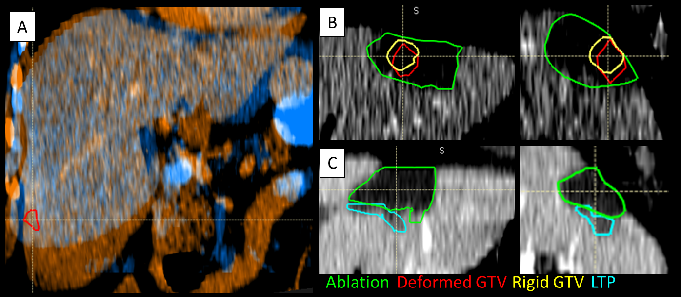
Figure 1: (B) Rigidly propagated gross tumor volume (Rigid GTV, yellow) appears to have sufficient ablation margin. However, deformed GTV (red) shows the disease proximal to caudal aspect of the ablation zone (green). (C) Local tumor progression (LTP, teal) corresponds geographically with insufficient ablation margin shown by the deformed GTV.

